Liège Winter Dance Intensive
Boarding school from 26 to 29 December 2024 at Yust Liège Guillemins
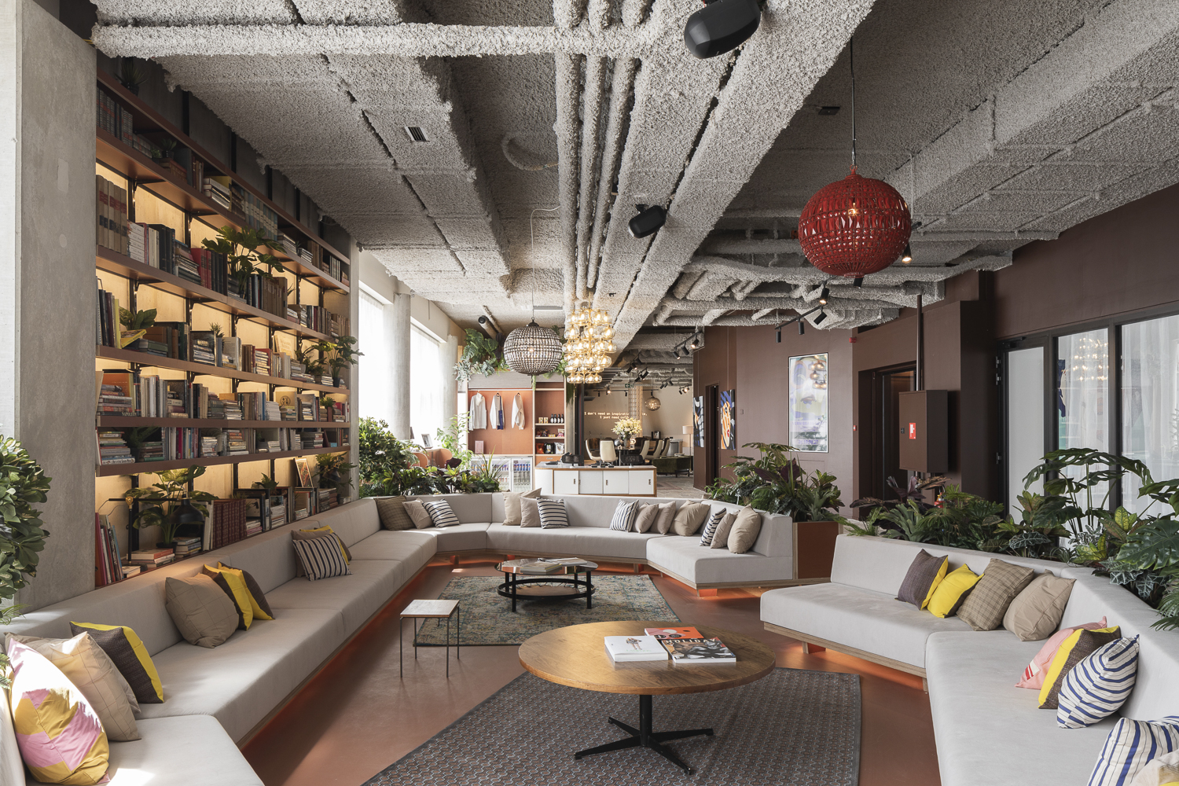
To ensure that students get the most out of the course and don't tire themselves out with unnecessary travel, we've set up an ideal package:
- Accommodation in a luxury 8-person dormitory
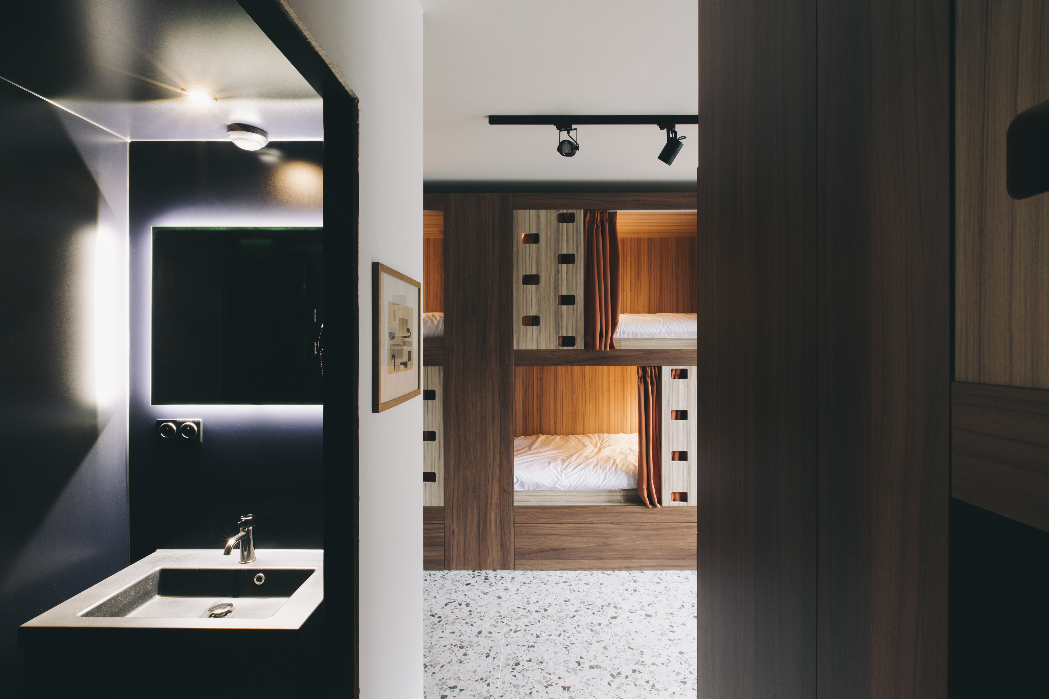

- Full board
- 24-hour supervisor
- Bus travel from the hotel to the studios, with at least one supervisor, except for the over-16s who may, with a written parental authorization, be free to travel on their own.
Hotel address: Esplanade Simone Veil 2, 4000 Liège (just in front of the Guillemans station)
Studio address: Opéra Royal de Wallonie, Place de l’Opéra, 4000 Liège
Travels will be made by bus and will take about 10 minutes.
To reserve your place, please fill in the form below. Please note that space is limited – first come, first served.
If you have any further questions, please contact us on infos@stagededanse.be
__________________________________

Accommodation Registration form Winter Intensive
I, the undersigned Mrs/Mr....................................................................., responsible for the child...................................................................... hereby register my daughter/my son for the accommodation package for the LIEGE WINTER DANCE INTENSIVE from 26 to 29 December 2024. I declare to have subscribed an insurance covering the accidents which could occur during the stay, and consequently, releases Stage de Danse asbl of any responsibility in the event of accident, of loss or theft.
Boarder contact details:
Last name:…………………………………….
First name:……………………………………..
Complete address: …………………………………
Email address:……………………………………….
Phone numbers: ………………………………………
For minors, name and phone number of the responsible person/emergency contact:
……………………………………………………………………………………………………
Selected package (tick the appropriate box):
- From Thursday 26 to Sunday 29, so 3 nights for €320 including full board
- I would like to arrive on December 25 and stay a night with the UNSUPERVISED accommodation (for under-18s, we will ask parents to sign an authorization form for this option), for a supplement of €60.
Meals:
- I have no food allergies
- I’m allergic to………………………………………..

Name and signature of a responsible person:

This form must be sent by e-mail to infos@stagededanse.be
We will get back to you as soon as possible to confirm your booking and give payment details.

We look forward to ending the year dancing with you, in the prestigious venue of the Opéra Royal de Wallonie!

Stage de Danse Team

